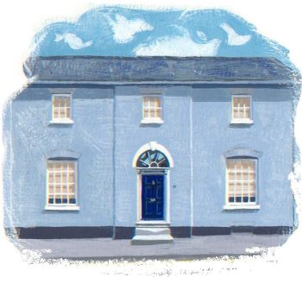
Safeguarding Vulnerable Adults

Wedgwood House Dental practice has a duty in preventing the abuse of vulnerable adults and responding promptly when abuse is suspected or reported.

We ensure that all our patients and staff are treated with courtesy, dignity, fairness and respect at all times. Our practice considers all incidents of abuse as being unacceptable and especially so when the victim is deemed to be vulnerable.

We will promote a culture and environment in which abuse of any kind is not tolerated and is dealt with promptly when it does occur.

This applies equally to every member of employed staff within Wedgwood House Dental Practice, regardless of occupation status or grade.

Any breach, including failure to properly report or investigate an allegation of abuse, will be treated as a disciplinary offence. This practice is committed to pursuing active equal opportunities and anti-discriminatory practices, whilst promoting and developing services and resources which are sensitive to age, culture, disability, ethnicity, gender, race, religion and sexuality.

This Practice is committed to ensuring that workers at all levels have the knowledge and ability to contribute effectively to the protection of vulnerable adults.

Wedgwood House Dental Practice Safeguarding Lead is Dr JM Geaney
Contact details: 01449 771 700
Other local contact details: jill.geaney@nhs.net

This Statement will be reviewed annually and is due for review on 1/5/2025 or prior to this date in accordance with new guidance or legislative changes.

