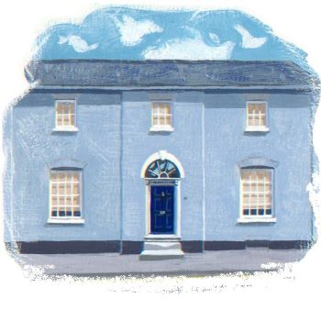
Safeguarding Children and Child Protection

To protect children within our care we are required to follow the child protection and safeguarding protocol. Our dental teams accept and recognise our responsibilities to develop awareness of the issues that cause children harm.

It should be stressed that our dental teams are not responsible for making a diagnosis of child abuse or neglect, just for sharing concerns appropriately.

We will endeavor to safeguard and protect children by:

- Adopting child protection guidelines through procedures and a code of conduct for the dental team.
- Making staff and patients aware that we take safeguarding children and child protection seriously and respond to concerns about the welfare of children.
- Using a multi-agency approach when sharing information about concerns with agencies who need to know and involving parents and children appropriately.
- Following carefully the procedures for staff recruitment and selection set out in our Recruitment Policy.
- Ensuring that all staff are enhance DBS checked (formerly CRB checked).
- Providing effective management for staff by ensuring access to supervision, support and training.

We follow good practice guidelines and are committed to reviewing our policies at regular intervals.

Wedgwood House Dental Practice Safeguarding Lead is Dr JM Geaney
Contact details: 01449 771 700
Other local contact details: jill.geaney@nhs.net

This Statement will be reviewed annually and is due for review on 1/5/2025 or prior to this date in accordance with new guidance or legislative changes.

